**CSR & Social Sector Service Data Analysis**

**1.Project Overview:**

* Business Analysis

Organizations invest in **Corporate Social Responsibility (CSR)** initiatives across sectors such as education, healthcare, environment, rural development, and skill development.  
The purpose of this analysis is to **understand how CSR funds and services are distributed**, identify **high-impact regions and sectors**, and highlight **gaps or under-served districts**.

* Objective of the Analysis

The main goals of this case study are:

* To analyze **distribution of CSR projects across districts and sectors**
* To identify **top and bottom performing districts**
* To understand **which sectors receive maximum CSR support**
* To evaluate **coverage gaps** (e.g., “Not Mentioned” districts/sectors)
* To provide **data-driven insights** for better CSR planning and decision-making

Data Cleaning & Preparation: Key steps performed

* Removing or handling **“Not Mentioned” / missing values**
* Standardizing **district name, state names according to their respective codes.**
* Correcting **data types** (text, numbers, dates)
* Removing duplicate
* Data Modeling:

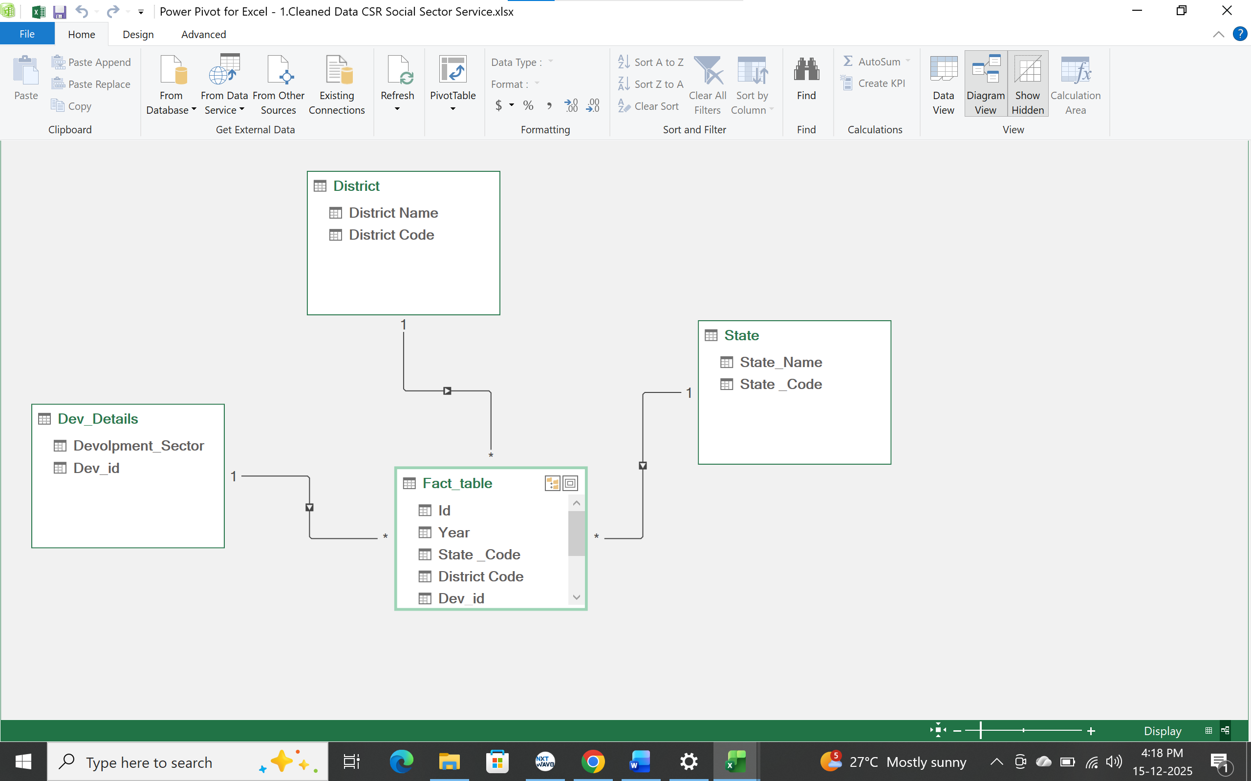

**2. Data Source:**

* Source Description and Timeline: Indian Data Portal/ CSR Projects/ Social Welfare/ 2014-2020/ Ministry of Corporate Affairs.
* Sector :Social Welfare/ Social Economic.

**3. Problem Statement:**

* **Analysis Scenarios**

The following analysis scenarios were addressed:

**District-Level Analysis**

* Highest CSR activity districts
* Bottom five districts by project count
* Districts with very low CSR coverage

**Sector-Level Analysis**

* Most funded / most active CSR sectors
* Least addressed sectors
* Sector distribution across states

**State-Level Comparison**

* States with maximum CSR participation
* Regional imbalance in CSR services

**4. Column Details:**

|  |  |  |
| --- | --- | --- |
| **Column Name** | **Data Type** | **Description** |
| **ID** | **Integer / String** | **Unique identifier for each State** |
| **State_Name** | **String (Text)** | **Name of the State** |
| **State_Code** | **Numeric (Integer)** | **Code of the state** |
| **Development_Sector** | **Categorical** | **Departments** |
| **Year** | **Numerical** | **Date** |
| **District_Name** | **String (Text)** | **Name of the District** |
| **District_Code** | **Numeric (Integer)** | **Code of the District** |
| **Dev_Id** | **String** | **Indicates the Development sector id** |
| **Project_outlay_amount_in_lakhs** | **Numerical** | **It shows the value of the porject outlay** |
| **Amount_spent_in_lakhs** | **Numerical** | **It gives the value of the amount spent on the project** |

**__________________________________________________________________________________**

**5. Tools & Techniques:**

* **Excel**
  + Data Cleaning
  + Sorting & Filtering
  + Relationship between dimensions table and fact table.
* Power BI for advanced visualization and querying(Charts, Bars, Tables, Slicers).

**6. Data Pre-Processing (Excel):**

**Tasks Performed:**

* Data Cleaning & Transformation**:** Removed duplicates, handled missing values, standardized formats, and created calculated fields.
* Filtering & Sorting: Organized data to focus on relevant records.
* Converted the data into Fact and DimensionTables. (Star Schema)

**7. Data Modelling and DAX (Power BI):**

* Data Model: Established relationships between tables, defined cardinality, its comes Star Schema.

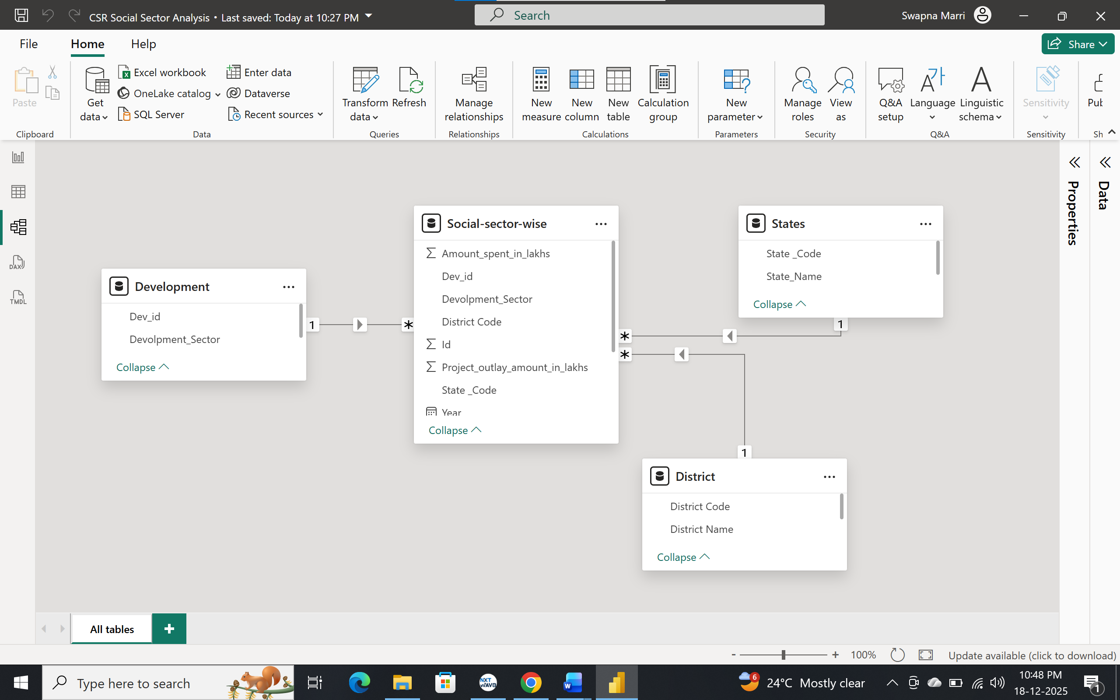

* Calculated Columns & DAX Measures**:** Implemented DAX formulas for key metrics, such as total projects, total states, total districts, total project outlay, total amount spent on project.

Created Measure:

1. Depwise_Rank = RANKX(ALL(Development[Devolpment_Sector]),CALCULATE(SUM('Social-sector-wise'[Project_outlay_amount_in_lakhs])),,DESC)
2. Total_projects = COUNT('Social-sector-wise'[Id])
3. Total_sectors = COUNT(Development[Devolpment_Sector])
4. Total_Districts = COUNT(Development[Dev_id])
5. Total_States = COUNT(States[State _Code])
6. Total_Project_Outlay = SUM('Social-sector-wise'[Project_outlay_amount_in_lakhs])
7. Count_Dev_Sectors = IF(ISBLANK(COUNT(Development[Devolpment_Sector])),BLANK(),COUNT('Social-sector-wise'[Dev_id])).
8. DAX Formula to create a Status:

Status = IF('Social-sector-wise'[Project_outlay_amount_in_lakhs]>'Social-sector-wise'[Amount_spent_in_lakhs],"Low Spend",IF('Social-sector-wise'[Project_outlay_amount_in_lakhs]<'Social-sector-wise'[Amount_spent_in_lakhs],"High Spend", "Exact Spend")).

1. Bottom 10 Projects outlays based on State Name Using a Measure:

Bottom10_ProjectOutlay = CALCULATE(SUM('Social-sector-wise'[Project_outlay_amount_in_lakhs]),FILTER(VALUES(States[State_Name]),RANKX(ALL(States[State_Name]),'Social-sector-wise'[Total_Project_Outlay],,ASC)<=10)).

**8.Analysis and Visualizations (Power BI):Analysis:** Cards based on data and Development sector Analysis:

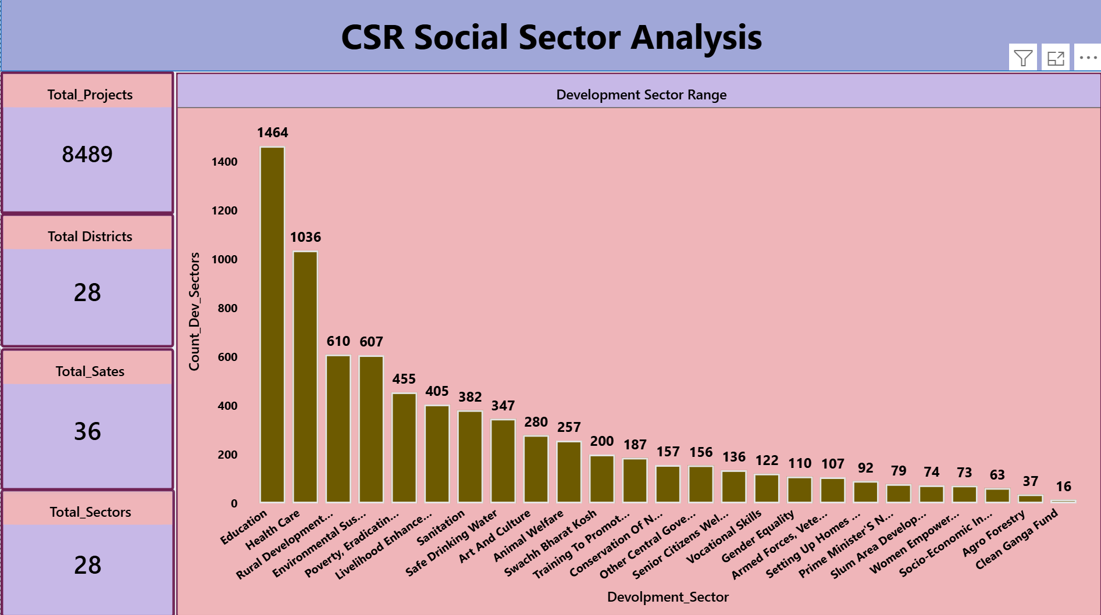

Top 10 sectors by Project Outlay And Amount spent on the Project Visuals, Slicers done for the Year, State Name, District Name. According to the slicer selection we get to know state or district

Analysis.

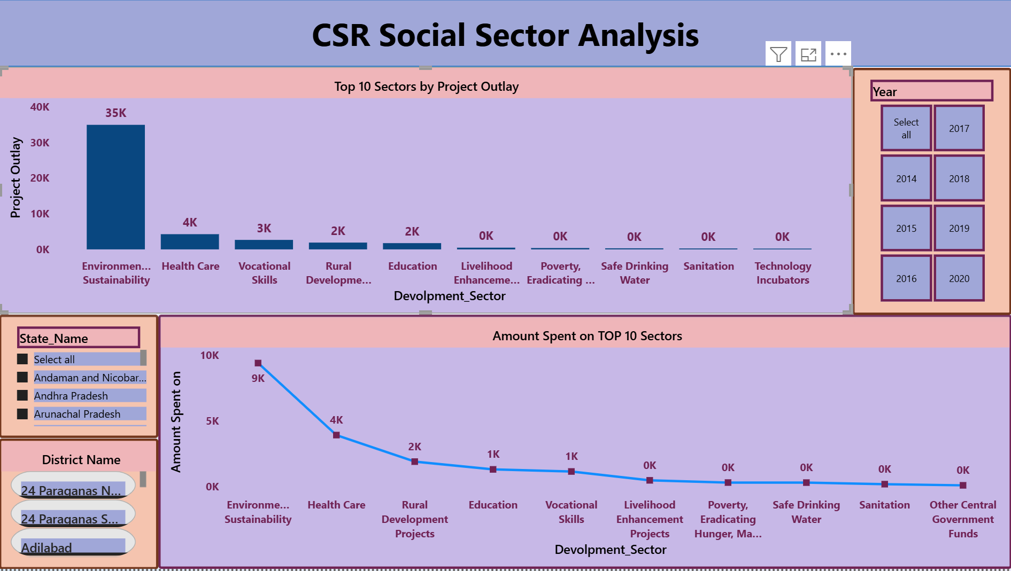

Amount spent on projects vs Project outlay: **Amount by created a conditional column based Project outlay and Amount spent Projects**

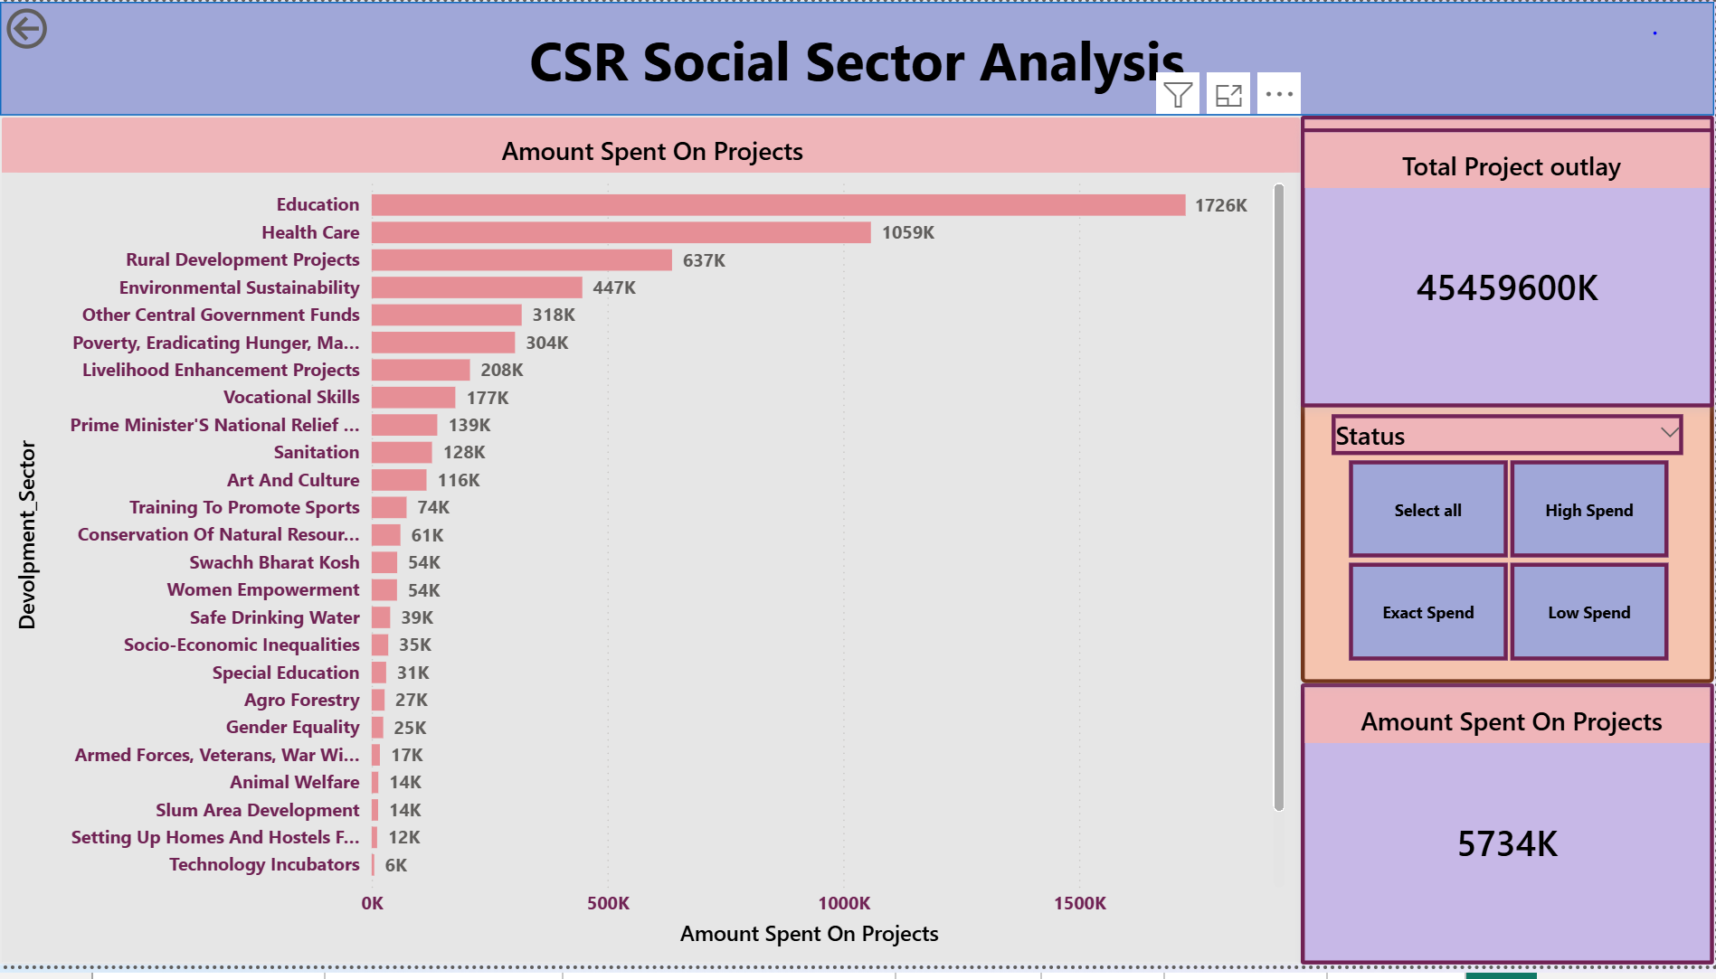

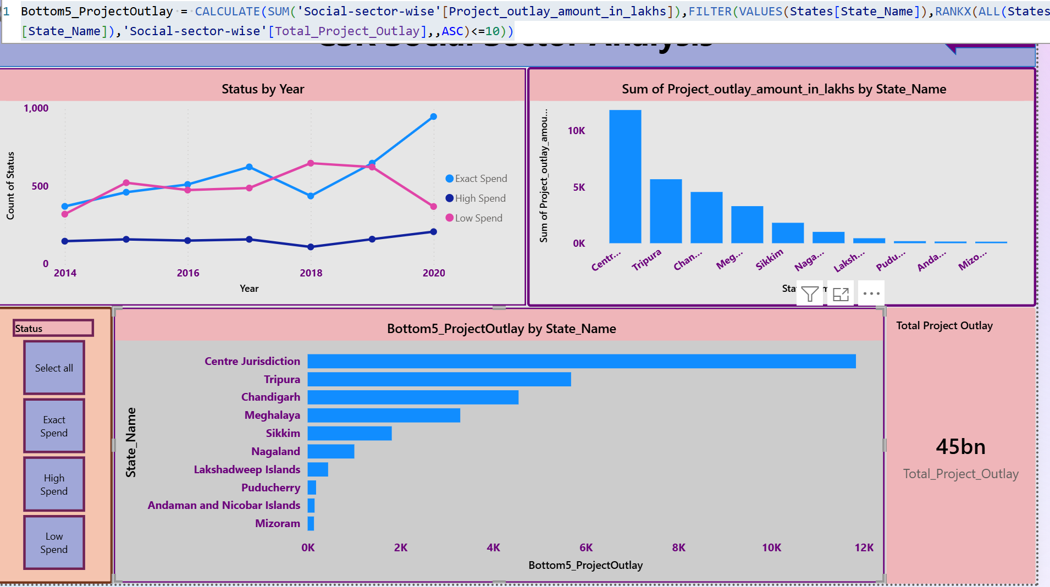

Matrix Created based on state name, district name, project outlay, amount spent on projects.

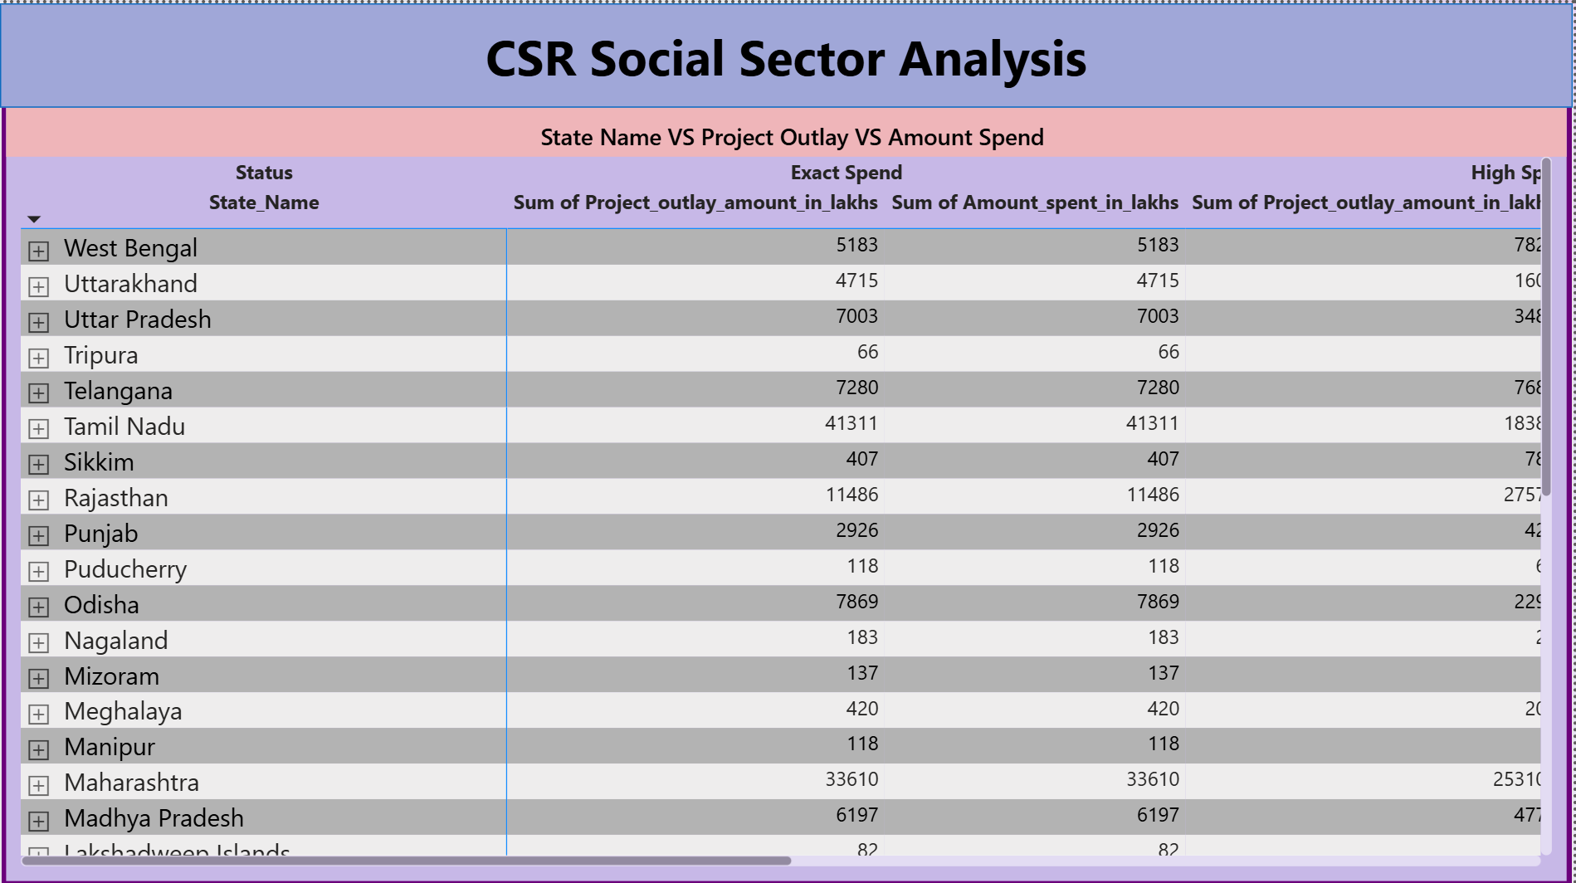

CSR Social Sector Analysis Report:

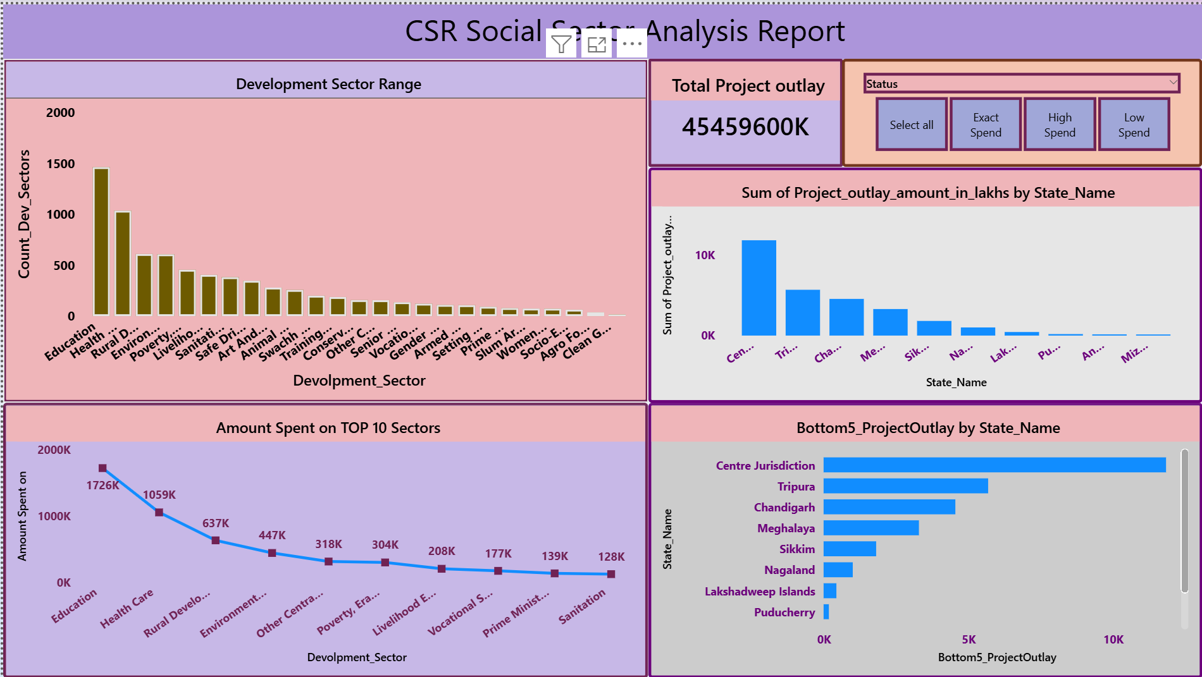

**9.Insights & Conclusions:**

Overall Project Distribution

* CSR projects are unevenly distributed across districts, indicating that development efforts are concentrated in a few regions.
* A small number of districts account for the highest share of total projects, while several districts show very low or negligible participation, highlighting regional imbalance.

1. **Descriptive Insights:** CSR activities are not evenly distributed across states and sectors, with strong concentration in specific districts and domains.

* The **total number of CSR projects** is concentrated in a limited number of districts.
* **Top 5 States** account for a disproportionately high share of projects compared to other regions.
* A few **development sectors dominate** the CSR landscape, indicating focused investment areas.
* Several districts/ states show **very low** highlighting uneven regional coverage.

1. **Diagnostic Analysis:** CSR concentration is driven by corporate proximity, ease of execution, and compliance behavior, rather than purely need-based development.

* High-performing states and districts are likely **industrial** attracting more CSR initiatives.
* Low-performing districts may suffer from:
  1. Lack of corporate presence
  2. Limited awareness of CSR programs
  3. Weak implementation capacity
* Sector dominance suggests companies prefer high-visibility, low-risk sectors (**e.g., education, healthcare).**

1. **Predictive Analysis:** Without strategic intervention, CSR initiatives will become more concentrated, increasing regional and sectoral inequality.

• Top districts will continue receiving the majority of CSR projects.

* Low-performing districts will remain underserved.
* Dominant sectors will continue to attract **most CSR funding**.

1. **Prescriptive Analysis:** Strategic reallocation, improved data governance, and impact-driven metrics can make CSR efforts more equitable, transparent, and effective.

* **Redistribute CSR focus** toward underserved and low-performing districts.
* Introduce **minimum State-level CSR allocation guidelines**.
* Encourage investment in **underrepresented development sectors**.
* Improve data quality by:

Standardizing district and development sectors.

**10. Conclusions:**

CSR activities appear to be more **compliance-driven than impact-driven** in some areas. There is a strong opportunity to:

* Expand CSR reach to underserved districts
* Align CSR projects with **regional development needs**
* Improve **equitable distribution of funds**

While CSR initiatives show strong activity in select districts and sectors, targeted policy intervention and data-driven planning are essential to ensure equitable and impact-focused development.